## Hijack DNS

### Subtask 1

Hijack a DNS query from your XP VM to PFSense. Capture the packets between your Kali

attacker and your victim. You should submit the following.

1. A screenshot showing your victim receiving the wrong website when they attempt to navigate to bing.com
2. A screenshot of where in the packet capture the DNS hijacking is taking place.

### 1. A screenshot showing your victim receiving the wrong website when they attempt to navigate to bing.com

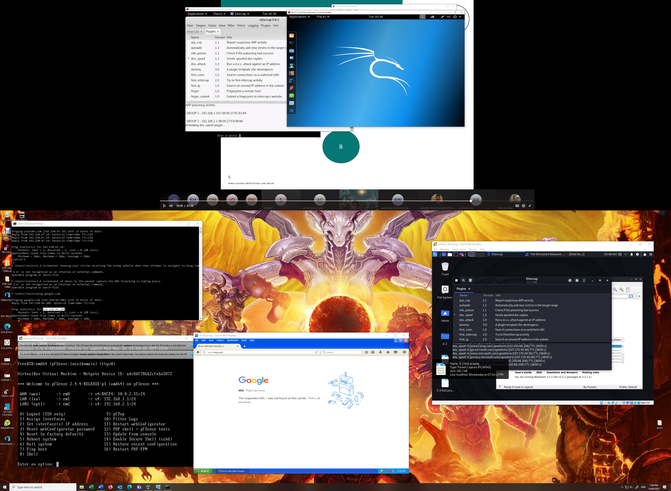

### 2. A screenshot of where in the packet capture the DNS hijacking is taking place.

